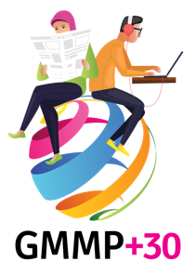

FEEDBACK FORM
The following information will be used by WACC as part of its evaluation of the GMMP 2025. Your input to this is much appreciated.

- Please comment briefly on the coding (i.e. the quantitative part of the project). Were the monitoring instructions clear? Was the coding system easy to use? Did you have any problems? Do you have any suggestions for the future?

- Please comment briefly on the relevance of the issues coded in GMMP 2025 to gender and media concerns in your country today, 30 years after Beijing. How relevant were the issues? What other issues would you like to have seen included?

- Please comment briefly on the qualitative analysis. Were the guidelines clear enough? Did you have any problems? Do you have any suggestions for the future?

- With regards to advocacy work, how does your organization plan to use the results of GMMP 2025?

- Are you willing to be involved in additional follow-up work over the next five years?

- Any other comments?

